# Identify all the different components you know in the following motherboards.

Number 1

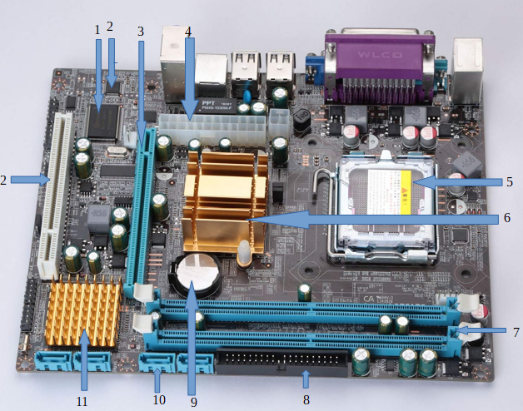

1. BIOS chipset

2. CMOS memory

3. AGP Slot NOPE

4. 20-pin ATX Power Connector

5. CPU Socket

6. Northbridge.

7. Memory slots

8. IDE connector

9. CMOS Battery

10. SATA port

11. Southbridge

12. PCI

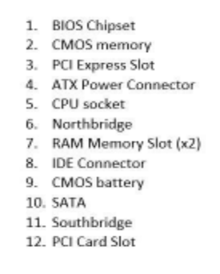

Number 2

PCI Express graphics card slot

PCI card slot

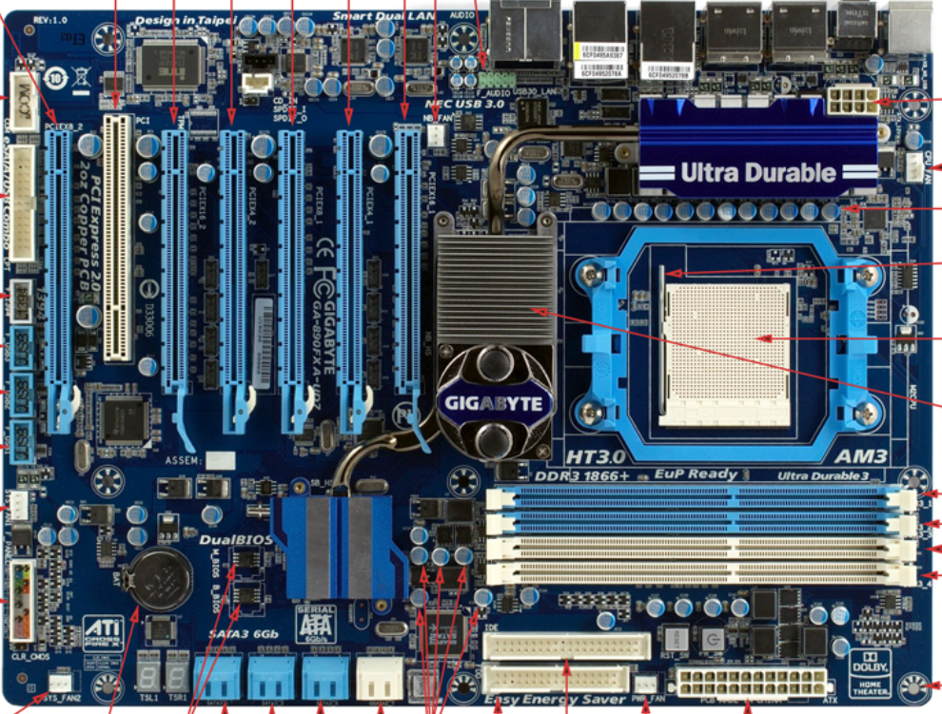

AUX-in

header

eSATA header

USB connectors

FAN connector

IDE connectors

ATAX power connector

CPU’s lever

Northbridge

CPU fan connector

SATA

RAM memory slots

CPU socket

capacitators

CMOS battery

CMOS memory

ATX power coonector

Extra port

PCI card slot

PCI express slots

Number 3

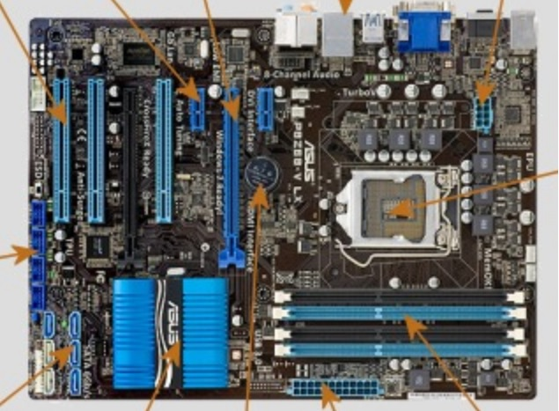

PCI slots

Serial port connector

SATA ports

CPU Socket

RAM slots

Dual channel

Southbridge

CMOS battery

ATX power coonector

Number 4

Heatsinks

ATX power

CPU Socket

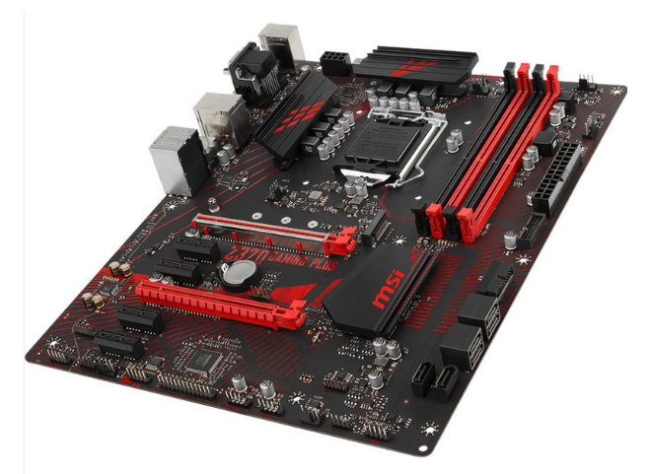

M.2 SSD

ATX power connector

PCI Express

Chipset

CMOS battery

SATA port

RAM slots

PCI card slots

Number 5

PCI

CPU socket

miniSATA

PCI express

CMOS battery

AGP

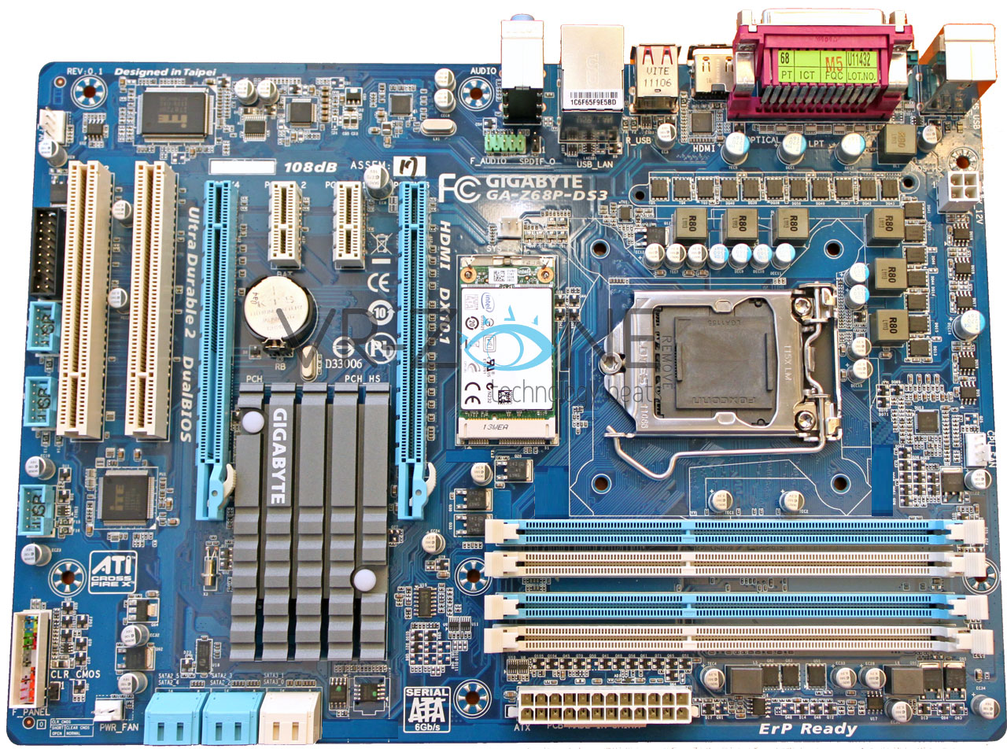

Fan connector

BIOS dual

ATX connector

Northbridge

RAM slots

Number 6

PCI express

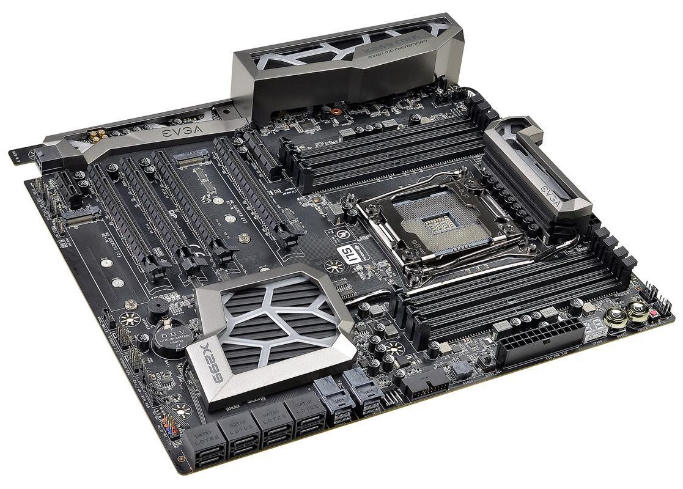

Southbridge

U.2 connectors

M2 memory

Northbridge

CMOS battery

ATX power Connector

PCIe

CPU Socket

RAM slots

SATA connectors

# Identify the external connectors in the following pictures

Number 1

Enthernet lan port

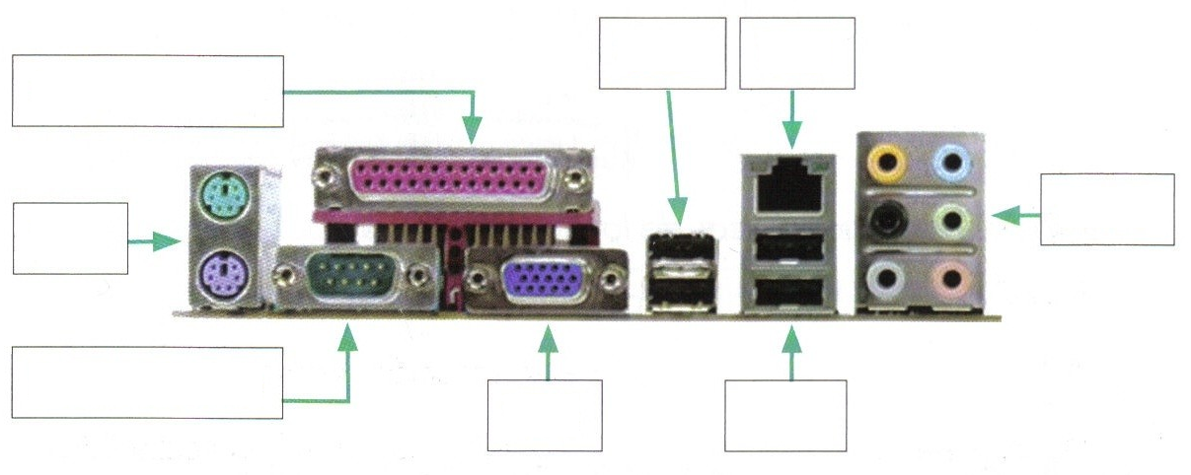

USB

USB a

Serial

Jack

SVGA

Parallel

PS/2

Number 2

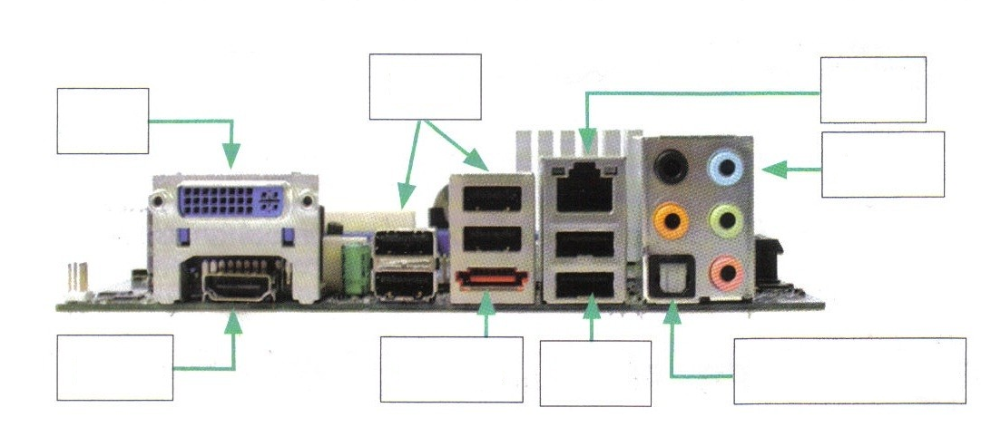

eSATA

USB

Enthernet lan port

Optical

HDMI

DVI-I (dual link)

Jack

USB

Number 3

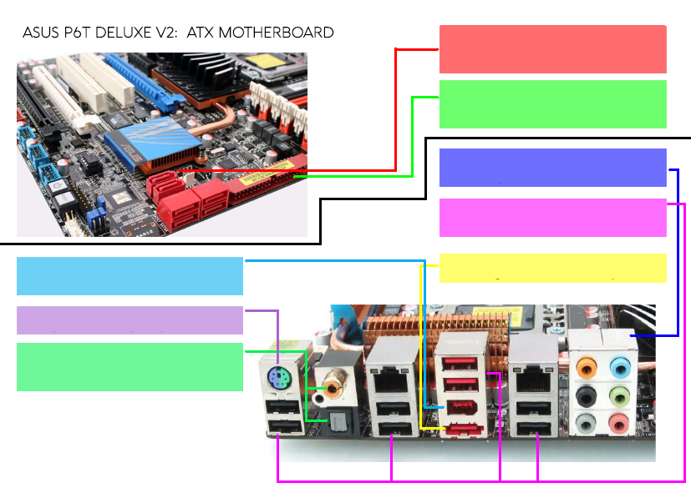

eSATA

Firewire

Jack

PS/2

S/PDIF

USB type A

IDE connector

SATA

Number 4

USB type A

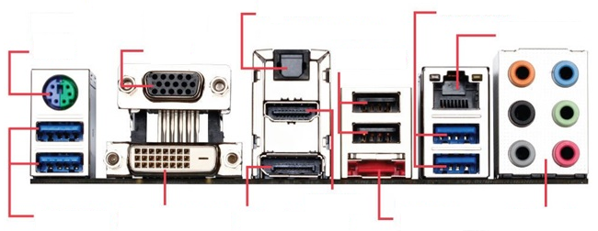

eSATA

S/PDIF

Ethernet lan port

Display port

USB type A

PS/2

SVGA

HDMI

DVI-D (Dual Link)

Jack